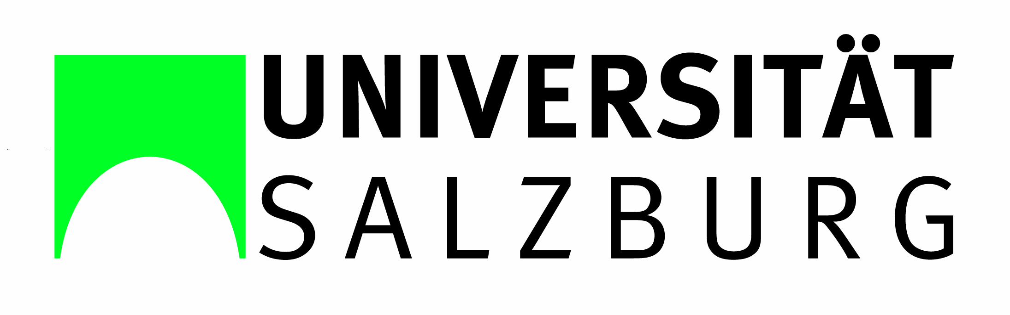 | 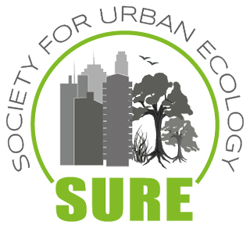

Sustainable Natural Resource Use in Arctic and High Mountainous Areas

SUNRAISE – SURE Summer School  URBAN + MOUNTAINS  7th – 14th of July 2019  Salzburg, Austria | 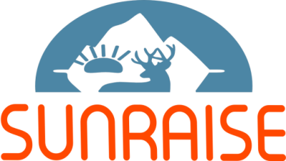

By the University of Salzburg, Austria, in cooperation with the Society for Urban Ecology (SURE)
The Summer School is organized under the Erasmus+ projects «Systems for Monitoring and Responses to Early Warnings»
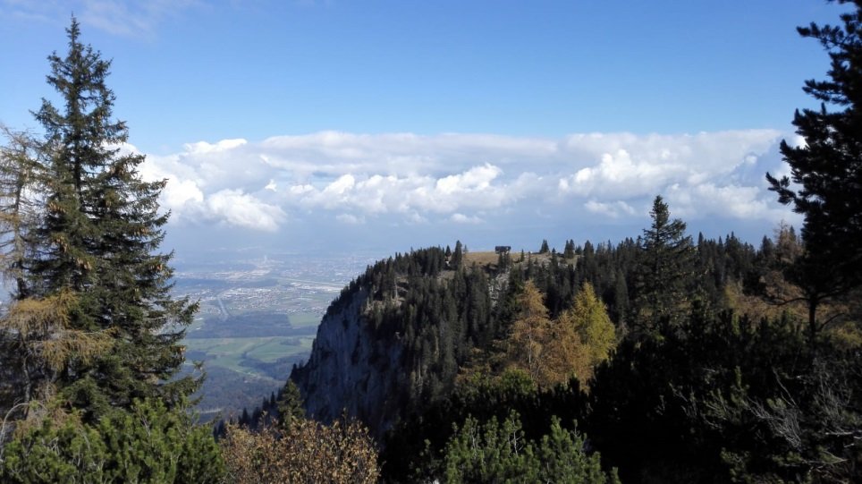

(c) Petra Pröll

The Summer School is organized by University of Salzburg (Austria) and the Society for Urban Ecology (SURE) in cooperation with Austrian an international partners. It is designed to explore and find solutions for human and environmental challenges, with the Alps, which are the Europe´s highest mountain system, set as the case study area.
The School will include training on research methodology and group work on multi-faceted research projects. The research part will be in connection of the Summer School from 15th till 21st of July.

Subjects:

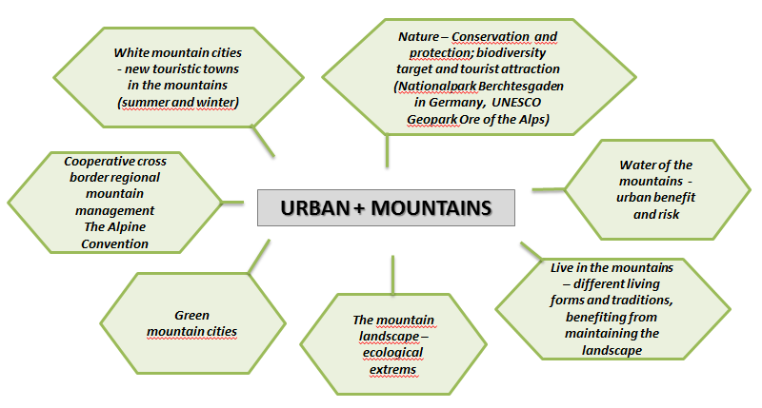

Preliminary program:

Sunday, 7th July | Arrival of the participants at the University of Salzburg
Monday, 8th July | SUNRAISE introductory day  Mountains – the special ecosystem  Lectures: 9:00 a.m. – 5:30 p.m.
Tuesday, 9th July | Urban in Nature – Nature in Urban  From Salzburg to Salzburg  Lectures: 8:30 a.m. – 5:30 p.m.  6:00 a.m. – 8:00 p.m. SURE EC Meeting (for SURE EC members)

Wednesday, 10th July | Urban mountains – special ecosystems  Lectures: 8:30 a.m. – 11:30 a.m.  1:00 p.m. – 5:00 p.m. Excursion Salzburg – mountain city  6:00 p.m. – 8:00 p.m. Summer School Exceptions
Thursday, 11th July | Mountain cities and towns:  The vertical dimension in urban ecosystems - Salzburg Students’ Day  Presentations: 8:30 a.m. – 7:00 p.m.
Friday, 12th July | Mountains between cultural landscapes and wildernesses – Nature protection in National Park Berchtesgaden  Excursion Day to the Nationalpark Berchtesgaden, Germany  Haus der Berge
Saturday, 13th July | Mountain Experience –  Excursion Day to the UNESCO Geopark Ore of the Alps, Bischofshofen, Austria
Sunday, 14th July | Departure or further work in Research Training

SUNRAISE – SURE Summer School
URBAN + MOUNTAINS
15th – 21th of July 2019

In connection to the Summer School, an individual field research will take place from the 15th till the 21st of July in and around the Salzburg region. During the Summer School from the 8th-14th of July we are going to offer a number of highly interactive lectures designed to familiarize the participants with the conditions/circumstances in the field. This will be followed by supervised group research and conclude with presentations of the research findings. The topics for the group-research will be identified by the students with the support of the lectures. To simplify the process, we will prepare comprehensive descriptions of the case studies.

How to apply
In order to participate on the Summer School, you need to submit a short CV and motivation letter.
The application deadline is May, 31st 2018
Application:

Petra Proell BSc,
petra.proell@sbg.ac.at
University of Salzburg, Urban landscape ecology

Summer School academic director:
Univ.-Prof. Dr. Jürgen Breuste
juergen.breuste@sbg.ac.at
University of Salzburg, Leader of the Research group Urban landscape ecology

